|  |  |
| --- | --- |
| **Source Bank 3:**  **Source 3A-** Martin Luther King, Jr., letter included in a *New York Times* advertisement soliciting funds for the SCLC, “Letter from a Selma, Alabama, Jail” February 1, 1965  **Source 3B-** Associated Press, photograph of protester John Lewis (foreground) being beaten by police on Bloody Sunday, March 7, 1965  **Source 3C-** Newspaper headlines from around the United States after Bloody Sunday  **Source 3D**- United States District Court, excerpt from the court brief seeking to lift Governor George Wallace’s injunction against the march (excerpts),*Williams v. Wallace*, March 1965  **Source 3E**- Lyndon B. Johnson, special message to Congress urging passage of the Voting Rights Act, “The American Promise” (excerpts), March 15, 1965 | |

SOURCE A:

NOTE: On February 5, 1965, the Southern Christian Leadership Conference (SCLC) paid to run a letter written by Dr. Martin Luther King, Jr. from a jail cell in Selma, Alabama in the*New York Times* as an advertisement. King’s impassioned appeal highlighted the irony of being jailed less than 60 days after receiving the Nobel Peace Prize, and he implored “decent Americans” to provide financial aid for the SCLC’s operations in Selma and many other southern cities and towns. Teachers and students can find an excerpt from the letter at the website of the Gilder Lehrman Institute of American History ([www.gilderlehrman.org](http://www.gilderlehrman.org/)) by performing an Internet search for “Gilder Lehrman + A Letter from a Selma, Alabama Jail.”

SOURCE B:

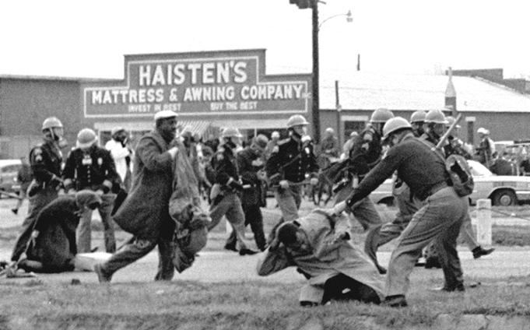

Caption: Protester John Lewis (foreground) being beaten by police on Bloody Sunday, March 7, 1965

©Bettmann/©Corbis/AP Images

SOURCE C:

Newspaper headlines from around the United States after Bloody Sunday

“Alabama Police Use Gas And Clubs To Rout Negros,”

*New York Times*, March 7, 1965, front page

“Alabama Negro March Explodes Into Bloody Violence With Police,”

Fitchburg *Sentinel* (MA), March 8, 1965, front page

“Tear Gas, Clubs Halt 600 in Selma March,”

*The Washington Post Times Herald*, March 8, 1965, front page

“Selma’s Mayor Blocks another March Attempt,”

*The Washington Post Times Herald*, March 11, 1965, front page

SOURCE D:

United States District Court, excerpt from the court brief seeking to lift Governor George Wallace’s injunction against the march (excerpts), *Williams v. Wallace*, March 1965

240 F. Supp. 100 Page 1

240 F. Supp. 100

(Cite as: 240 F. Supp. 100)

United States District Court, M.D. Alabama, Northern Division.

Hosea WILLIAMS, John Lewis and Amelia Boynton, on behalf of themselves and others similarly situated, Plaintiffs, United States of America, Plaintiff-Intervenor,

v.

Honorable George C. WALLACE, as Governor of the State of Alabama, Al Lingo, as Director of Public Safety for the State of Alabama, and James G. Clark, as Sheriff of Dallas County, Alabama, Defendants.

Civ. A. No. 2181-N. March 17, 1965.

Order March 19, 1965.

Action against the governor of the state of Alabama and other officials to restrain their interference with plaintiffs’ proposed march, wherein the United States by leave of court filed its complaint in intervention. The District Court, Johnson, J., held, inter alia, that evidence warranted issuance of injunction restraining defendants from interfering with proposed march by Negro citizens and other members of their class along U.S. Highway 80 from Selma to Montgomery for purpose of petitioning their government for redress of their grievances in being deprived of right to vote.

[10] This Court finds the plaintiffs’ proposed plan to the extent that it relates to a march along U.S. Highway 80 from Selma to Montgomery, Alabama, to be a reasonable one to be used and followed in the exercise of a constitutional right of assembly and free movement within the State of Alabama for the purpose of petitioning their State government for redress of their grievances….This is particularly true when the usual, basic and constitutionally-provided means of protesting in our American way—voting—have been deprived. [FN6]

PLAINTIFFS’ PROPOSED PLAN FOR MARCH FROM SELMA, ALABAMA, TO MONTGOMERY, ALABAMA

1. The march will commence on Friday, March 19, 1965 at 10:30 a.m. or any day thereafter provided that plaintiffs will provide at least 48 hours advance notice of the march to Defendants, the United States, and the Court.

2. The number of persons marching will be as follows:

A. There will be no limitation on the number of marchers within the Cities of Selma and Montgomery and along the 4-lane portions of Route 80-East between Selma and Montgomery.

B. The number of marchers will not exceed 300 persons on the 2-lane portion of Route 80.

3. The following are the approximate distances to be covered each day:

A. First Day-march approximately 11 miles stopping at a designated private field with permission of owner which has already been granted;

B. Second day-march approximately 11 miles stopping at a designated field with permission of the owner which already has been granted;

C. Third day-march approximately 17 miles stopping at a designated building and adjoining field with permission of owners which has already been granted;

D. Fourth day-march 8 miles to the western part of Montgomery stopping at an area tentatively selected and to be designated.

E. Fifth day-march from western part of Montgomery to the Capitol.

F. Large tents will be erected at the campsites by professionals. Meetings and song festivals may be held at campsites….

…

6. On the highway, the marchers will proceed on shoulders of the road walking on the left side facing automobile traffic. They will march along road shoulders two abreast and employ single files at places where the shoulder is narrow and on bridges without sidewalks. The marchers will be organized in separate groups of approximately 50 persons (or less) and each group will be under the supervision of a designated group leader.

7. The following supporting services will be provided:

A. Food.

B. Truck-borne washing and toilet facilities.

C. Litter and garbage pickup by truck along route and at campsites.

D. Ambulance and first aid service.

E. Transportation for return to Selma of those marchers in excess of the 300 (or fewer) persons who will continue on the march after the first day. Transportation will also be available for some persons who will join the group on the last day to complete march by entry into Montgomery. F. Lines of communication among the marchers and leaders and certain supporting services will be established by walkie-talkie radios and other means.

8. Liaison will be established between designated leaders of the march and such *121 state and local officials as the agencies concerned shall designate.

Public domain.<http://new.gilderlehrman.org/sites/default/files/inline-pdfs/Williams_Wallace.pdf>.

SOURCE E:

Lyndon B. Johnson, special message to Congress urging passage of the Voting Rights Act, “The American Promise” (excerpts), March 15, 1965

Mr. Speaker, Mr. President, Members of the Congress:

I speak tonight for the dignity of man and the destiny of democracy. I urge every member of both parties, Americans of all religions and of all colors, from every section of this country, to join me in that cause.

At times history and fate meet at a single time in a single place to shape a turning point in man's unending search for freedom. So it was at Lexington and Concord. So it was a century ago at Appomattox. So it was last week in Selma, Alabama.

There, long-suffering men and women peacefully protested the denial of their rights as Americans. Many were brutally assaulted. One good man, a man of God, was killed.

There is no cause for pride in what has happened in Selma. There is no cause for self-satisfaction in the long denial of equal rights of millions of Americans. But there is cause for hope and for faith in our democracy in what is happening here tonight.

For the cries of pain and the hymns and protests of oppressed people have summoned into convocation all the majesty of this great Government—the Government of the greatest Nation on earth. Our mission is at once the oldest and the most basic of this country: to right wrong, to do justice, to serve man.…

There is no Negro problem. There is no Southern problem. There is no Northern problem. There is only an American problem. And we are met here tonight as Americans—not as Democrats or Republicans—we are met here as Americans to solve that problem.…

Our fathers believed that if this noble view of the rights of man was to flourish, it must be rooted in democracy. The most basic right of all was the right to choose your own leaders. The history of this country, in large measure, is the history of the expansion of that right to all of our people.

Many of the issues of civil rights are very complex and most difficult. But about this there can and should be no argument. Every American citizen must have an equal right to vote. There is no reason which can excuse the denial of that right. There is no duty which weighs more heavily on us than the duty we have to ensure that right.…

Wednesday I will send to Congress a law designed to eliminate illegal barriers to the right to vote.…

This bill will strike down restrictions to voting in all elections—Federal, State, and local—which have been used to deny Negroes the right to vote.

*[ Emphasis added.] This bill will establish a simple, uniform standard which cannot be used, however ingenious the effort, to flout our Constitution….*

Public domain. Public Papers of the Presidents of the United States: Lyndon B. Johnson, 1965. Volume I, entry 107, pp. 281-287. Washington, DC: Government Printing Office, 1966. A transcript is available at the LBJ Library website, at<http://www.lbjlibrary.org/lyndon-baines-johnson/speeches-films/president-johnsons-special-message-to-the-congress-the-american-promise>, along with video of the speech, at [http://www.lbjlibrary.org](http://www.lbjlibrary.org/)/lyndon-baines-johnson/speeches-films/president-johnsons-special-message-to-the-congress-the-american-promise.