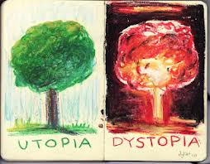 **Do Now’s for the week of October 20-24 2014**

|  |  |
| --- | --- |
| Monday,  Oct. 20, 2014 | Write a reaction to the biography that we read last Friday…  • What was Ray Bradbury saying about the world in 2053?  • What were his opinions on technology and television?  __________________________________________________________________  __________________________________________________________________  __________________________________________________________________  __________________________________________________________________ |
| Tuesday,  Oct. 21, 2014 | Take a few minutes to summarize what you know about a **dystopia.**  _________________________________________________________________  _________________________________________________________________  _________________________________________________________________  _________________________________________________________________ |
| Wednesday,  Oct. 22, 2014 | Take a few minutes to summarize what you know about a **Utopia.**  _____________________________________________________________  _________________________________________________________________  _________________________________________________________________  _________________________________________________________________ |
| Thursday,  Oct. 23, 2014 | Explain in three 7up + quality sentences what is a society?  _________________________________________________________________  _________________________________________________________________  _________________________________________________________________  _________________________________________________________________ |
| Friday,  Oct. 24, 2014 | Write a quality paragraph explaining just what is the difference between a Utopia and a Dystopia? Be specific in your explanation.  (Use the back for more space)  ________________________________________________________  ________________________________________________________  ________________________________________________________  ________________________________________________________.  Today you’re going to repeat what we did last week. I want each one of you to check your grades on **Power School**. Record them all onto the back of the Do Now. |