**To Make a Prezi Account**

If you haven’t used Prezi before, you’ll want to make an account.

Go to **prezi.com**

Then, click on the <**Sign Up**> tab top right corner.  It will take you to the page <**Choose a License**>, select <**Student/Teacher Licenses**>, and then the column **Edu Enjoy**  and <**Get**>.  You will need to use your district email to be verified as an active teacher for an education account (more features).

Use **Sunnyside Unified School District** as the School Name, and the main SUSD website [www.susd12.org](http://www.susd12.org) as the address:

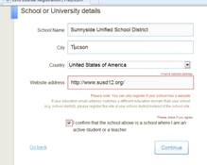

They will send you a confirmation in your district email, click on it and you are set.

