Review of Literary Terms
Type | Definition | Examples from… The Lottery, The Pedestrian, &  There will come Soft Rain.
Suspense
Foreshadowing
Flashback
Symbolism | The use of symbols to represent ideas or qualities. | Symbol Meaning  Delacroix Of the cross
Characterization  - Directly  - Indirectly | Characterization is the process by which the writer reveals the personality of a character.
Plot Map  - Exposition  - Rising action  - Climax  - Falling action  - Resolution | Plot refers to the series of events that give a story its meaning and effect. In most stories,  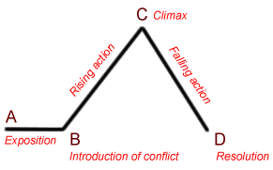
Irony  - Verbal  - Situational  - Dramatic | Irony is a figure of speech in which words are used in such a way that their intended meaning is different from the actual meaning of the words.
Conflict  - Internal  - External | Conflict is a struggle between two or more forces that creates a tension that must be resolved
Point of View

- First person

- Third person (Limited)

- Third person (Omniscient)
Figurative Language

- Simile

- Metaphor

- Personification

- Hyperbole

- Idiom

- Alliteration

- Onomatopoeia

