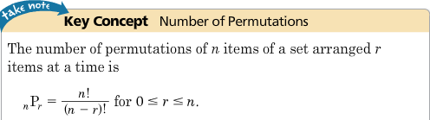**Chapter 11 Reference Sheet**

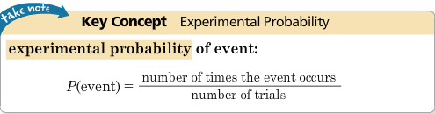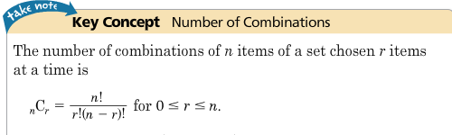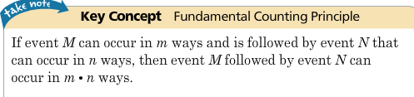

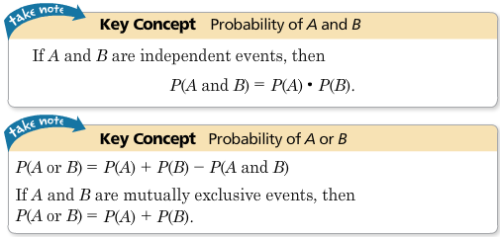

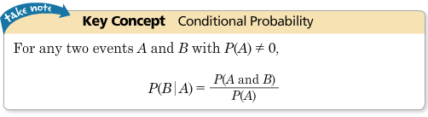

**A number cube has 6 sides with the numbers 1, 2, 3, 4, 5, and 6 on them.**

**A regular deck of cards has 52 cards.**

**There are 4 cards with kings, 4 cards with queens, 4 cards with jacks on them. These are called “FACE” cards.**

**There are 4 cards with aces, and 4 cards each of 2’s, 3’s, 4’s, 5’s, 6’s, 7’s, 8’s, and 9’s.**