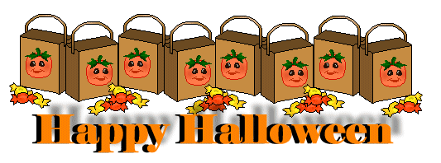

|  |  |
| --- | --- |
| Monday,  Oct. 27, 2014 | Quick write for 2 to 3 minutes the following statement…  How does a warm, clear summer day make you feel?  __________________________________________________________________  __________________________________________________________________  __________________________________________________________________  __________________________________________________________________ |
| Tuesday,  Oct. 28, 2014 | “What would you do if you won the lottery”? List the five most important things you would do with your winnings|
| Wednesday,  Oct. 29, 2014 | “What are some of the differences between the lottery in the past and the lottery today?  ____________________________________________________________  _________________________________________________________________  _________________________________________________________________  _________________________________________________________________ |
| Thursday,  Oct. 30, 2014 | What does the symbolic meaning of the black box, black dot, and the stones within the story?  _________________________________________________________________  _________________________________________________________________  _________________________________________________________________  _________________________________________________________________ |
| Happy Halloween!  Friday,  Oct. 31, 2014 | Today you’re going to repeat what we did last week. I want each one of you to check your grades on **Power School**. Record them all onto the back of the Do Now. |

**Use the back for answering Friday’s Happy Halloween Do Now!**