11.6 Day 1 Name __________________________ Per. _____

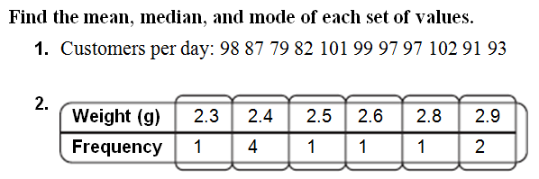

**Remember: Frequency 4 means “2.4, 2.4, 2.4, 2.4”**

