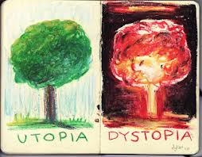 **Do Now’s for the week of October 13-17, 2014**

|  |  |
| --- | --- |
| Monday,  Oct. 13 , 2014 | Quick write…If you could dream of the perfect school, what would it look like? Be specific with your description.  __________________________________________________________________  __________________________________________________________________  __________________________________________________________________  __________________________________________________________________ |
| Tuesday,  Oct. 14,2014 | Pick two **new words** from either yesterday or today and use them in quality Seven Up plus sentences.  1.  2. |
| Wednesday,  Oct. 15, 2014 | Justify this statement in your own words by using your Cornell Notes from Monday… “What is a Society?”  _________________________________________________________________  _________________________________________________________________  _________________________________________________________________  _________________________________________________________________ |
| Thursday,  Oct. 16 , 2014 | Which **word** does not describe a **dystopia society**: Justify your answer with unquestionable validity.  a. Miserable  b. Technological  c. Structured  d. peaceful  _________________________________________________________________  _________________________________________________________________  _________________________________________________________________ |
| Friday,  Oct. 17, 2014 | Today you’re going to try something different. I want each one of you to check your grades on **Power School**. Record them all onto the graphic organizer handed to you as you came into the room… and do exactly what is instructed. Then, turn in the “Do Now” and begin reviewing **“the Pedestrian”** from yesterday. |