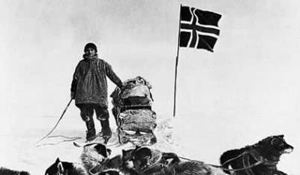**Guided Questions / Text-Specific Questions**

|  |  |
| --- | --- |
| **2-What do I learn about the topic as I read (view)?** | **1-How is the text (video) organized?** |
| **3-What details from the video suggest how difficult it was to survive the journey to the Pole?** | **4-Why does Amundsen say "it was like being a boy again" to reach the Pole first?** |
| **Reflect on the “close reading” experience of watching a video, using the Reading Closely Checklist to guide the reflective discussion. This reflective discussion is an opportunity to self-assess your ability to read closely and identify areas where you can improve as a reader over the course of this unit.** | **5-At the end of the video, what does Amundsen suggest when he says, "Victory awaits him, who has everything in order. Luck we call it."?** |