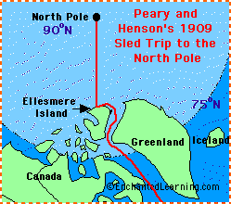 **Robert Edwin Peary: Arctic Explorer**

Robert Edwin Peary (May 6, 1856 - Feb. 20, 1920)

was an American explorer and Naval officer who led the

first expedition to the North Pole. In 1909, Peary, Matthew A. Henson,

and four Eskimos were the first people to reach the North Pole.

In 1908, after having already attempted two trips to the North Pole, Peary and his party sailed to Ellesmere Island (at the far north of Canada) on the USS Roosevelt. In early March, 1909, the expedition (Matthew A. Henson, Dr. John W. Goodsell, Donald B. MacMillion, Ross G. Marvin, George Borup and Captain Robert Bartlett) left their base camp at Cape Columbia and headed north in dog sleds (which Henson built). Peary, Henson and four Eskimos reached the North Pole on April 6, 1909 (the others turned back at various places along the way). It is now thought that Peary and Henson may have been 30-60 miles (50-100 km) short of reaching the pole (because of navigational mistakes that were made). Frederick A. Cook (who had accompanied Peary on an earlier expedition) later claimed to have reached the North Pole before Peary, in April 1908; this claim was later rejected completely as a cruel hoax.

Peary led many earlier expeditions, including explorations of Nicaragua (looking for a good location for a canal linking the Atlantic and Pacific Oceans). These exploratory trips included:

1888 (Nicaragua)

1891-92 (Nicaragua)

1893-95 (with Hugh J. Lee and Henson: charted the ice cap of Greenland - the expedition members almost starved to death) Peary was awarded a Congressional medal in 1944 for his polar expedition

1896 (meteorite collection in the Arctic)

1897 (meteorite collection in the Arctic)

1898-1902 (many Arctic expeditions)

1905-06 (North Pole - they only made it to 87°06' N)

1908-09 (North Pole - successful)

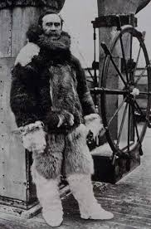**Robert E. Peary Quiz**

1. In what year was Peary born? __________________________________

2. Robert E. Peary led the first expedition to travel successfully to what famous spot on the globe? ______________________________

3. In what year did this occur? __________________________

4. What was the name of the American man who accompanied Peary to this destination? He was Peary's partner on this and many other expeditions. __________________________________

5. What is the name of the island at the far north of Canada to which the expedition sailed and on which they set up their base camp? __________________________________

6. What type of transportation did the team use to travel over the snow? __________________________________

7. Peary made many exploratory trips. Where in Central America did he explore to try to find a good location in which to build a canal to link the Atlantic and Pacific Oceans? __________________________________

8. One of Peary's early expeditions was almost a disaster, and the members almost starved to death. What area was this expedition charting? __________________________________

9. Peary also went on expeditions to collect valuable, unusual objects in the Arctic. What were these objects? __________________________________

10. In what year did Peary die? __________________________________