**Apollo Middle School**

**265 W. Nebraska Tucson, AZ 85706**

**(520) 545-4500**



**Apollo**

**School-wide**

**Behavior Intervention &**

**Classroom Management**

**2014-2015**

“[**Be a reflection of what you'd like to see in others! If you want love, give love, if you want honesty, give honesty, if you want respect, give respect. You get in return, what you give!**](http://16quotes.com/if-you-want-respect-give-respect-you-get-in-return-what-you-give/)”

-[Unknown](http://16quotes.com/quotes/author/unknown-quotes/)

“[**Treat people the way you want to be treated. Talk to people the way you want to be talked to. Respect is earned, not given.**](http://16quotes.com/talk-to-people-the-way-you-want-to-be-talked-to/)”

-[Hussein Nishah](http://16quotes.com/quotes/author/hussein-nishah/)

**“Treat everyone you meet as though they are the most important person you'll meet today.”**

**-**Roger Dawson

**“Love and respect are the most important aspects of teaching, and of all relationships.”**

-[Jodie Foster](http://www.values.com/inspirational-quote-authors/1231-Jodie-Foster)

Above are a few quotes to ponder upon as we think about how we are going to set up our classroom procedures, expectations, and rules. It will be our goal this year to be models of RESPECT for our students so that they feel respected and valued. If we expect RESPECT from our students…then RESPECT is what they shall receive.

It is also our goal that the school-wide goal is to be a model of BE the THREE each day!!!

Apollo Eagles  
BE the THREE



**RESPECTFUL**

Treat everyone with kindness and compassion.

Use appropriate speech at all times.

**RESPONSIBLE**

Stay focused and on task.

Do it RIGHT the first time!

Take care of school and personal property

**RELIABLE**

Be truthful and maintain a positive attitude.

Be on time, all the time.

Effort equals results!

We also have a Matrix of Expected Behaviors that we have in place in order to provide our students with the knowledge of how they are expected to behave and act in each of the eight areas listed in the matrix. It is our goal to teach the expected behaviors and hold our students accountable for being a good model daily of the expectations.

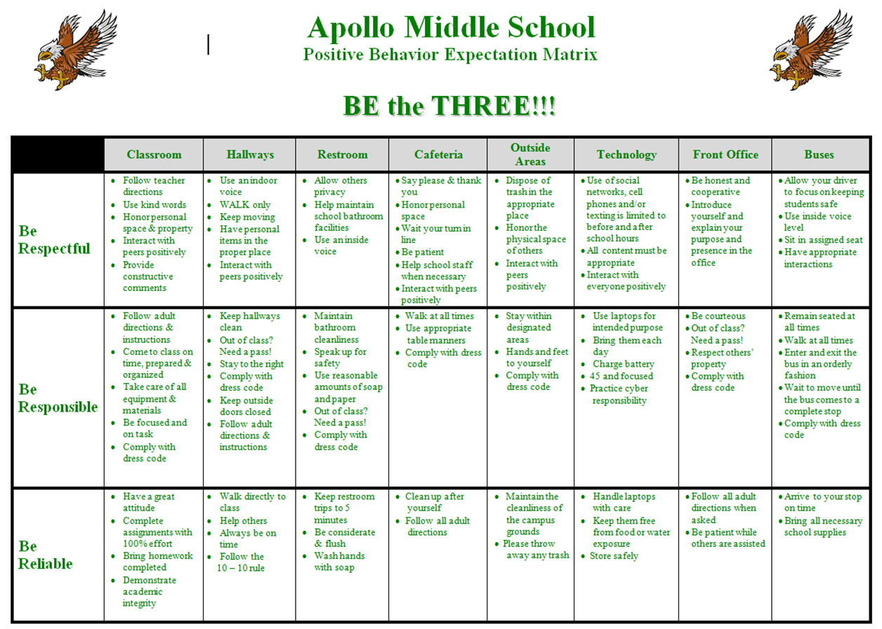



**RESPECTFUL**

Follow teacher directions

Use kind words

Honor personal space & property

Interact with peers positively

Provide constructive comments

**RESPONSIBLE**

Follow adult directions & instructions

Come to class on time, prepared & organized

Take care of all equipment & materials

Be focused and on task

Comply with dress code

**RELIABLE**

Have a great attitude

Complete assignments with 100% effort

Bring homework completed

Demonstrate academic integrity

**BE the THREE**

**CLASSROOM**

**In order for our school-wide expectations to be meaningful for our students to follow…we must make a commitment to teach the expected behaviors and expect our students to be models of the expected behaviors in all eight areas of the matrix. It is also necessary to develop procedures and protocols with each classroom that align to the matrix of expected behaviors as well. Therefore, we have to be committed to the following responsibilities.**

**Teacher and Staff Classroom Procedures Expectations:**

* Teachers and staff will teach, model and practice each of the behavioral expectations throughout the year…especially the first weeks of the new school year and a review at the start of each quarter.
* Post and review the Apollo School Rules regularly
* Teachers and staff will acknowledge positive student behaviors and provide positive feedback/incentives.
  + Eagle Bucks, Be the Three Free Dress Pass, Class Dojo Points, etc.
* Teachers and staff will implement the CHAMPS strategy as a protocol for establishing a routine and procedure for classroom activity.

**CHAMPS for DIRECT INSTRUCTION**

**C**onversation: none ~ unless responding to a question by the presenter or troubleshooting

**H**elp: raise your hand to ask a question(s) or ask 3 before me if you are troubleshooting

**A**ctivity: taking notes, listening and following presenter’s directions

**M**ovement: none, stay seated (Unless fire drill or lockdown)

**P**articipation: writing, nodding, making eye contact with the presenter, or typing on laptop

**S**uccess: if followed Success will occur

**CHAMPS for GROUP WORK**

**C**onversation: indoor voices used with group members

**H**elp: ask 3 before me and then raise your hand

**A**ctivity: cooperate with group members to complete the assignment

**M**ovement: sit with your group

**P**articipation: write, read, discuss and cooperate respectfully

**S**uccess: if followed Success will occur

**CHAMPS for INDEPENDENT WORK**

**C**onversation: none

**H**elp: raise your hand to ask a questions

**Ac**tivity: quietly read, write, type and sit

**M**ovement: none, stay seated (Unless fire drill or lockdown)

**P**articipation: work by yourself to complete the assignment

**S**uccess: if followed Success will occur

**Classroom Management Strategies**

* Building and developing Positive Relationships with students is the **key** to success with your students this year.
* Set up your classroom to be “student-friendly”. Arrange desks/tables for easy teacher access to all students.
  + Classroom procedures, expectations, and school rules/expectations are posted in the classroom.
  + Establish daily routines and procedures for activities (CHAMPS), movement, restroom use, getting a drink of water, entering/exiting procedures, etc.
  + Set an RT Table that is isolated away from the main classroom desks/tables that will be available for a student to complete an RT Reflection form.
* Create a seating chart and have it readily available for a substitute/guest teacher. Please update the seating chart periodically when you make changes to it.
* Develop a Signal Word or Hand-Motion Signal to get the attention of your students.
  + Please post this Signal Work or Hand-Motion Signal so that it is available for review and also available when you have a substitute or guest teacher.
* During instruction, teachers should walk about to monitor and check-in with students around the room.
* During instruction challenging students should not be in the corner or back of the room, but within two to three feet of the teacher. Proximity and eye contact work wonders for increasing positive student behavior.
* Keep students on task with instructional activities at least 85% or more during academic classes (research states that effective teachers know that unstructured time—or down time—causes problems).
* Reward all students who are following procedures in a positive way with praise, note or phone call home, privileges, field trips; or tangible incentives like raffle tickets, lucky horseshoes, etc.
* Post a schedule in an obvious place and follow it. Students need to know the daily routine and expected goals.
* Teach students the CHAMPS expectations for completing classroom activities. Never assume that a student will know what you expect from them.
* Collaborate with colleagues (a Time Out Buddy) in the vicinity of your classroom to provide a place for students to be timed-out.
* Look for classroom-tested resources and reinforcement strategies online to motivate and manage challenging or “tough kid” students. Positive reinforcement strategies are excellent for boosting good behavior and learning.
* Speak with other staff members who have worked with a challenging student. Find out what interventions have worked best for them. Collaborate with colleagues to learn about “best” practices and strategies.

**We all know that there will be students who will challenge us daily and not live up to being a positive model of the expected behaviors. Therefore, it is important to know the steps that must be followed prior to sending a student to the Office of Student Relations to receive a disciplinary consequence.**

**Classroom Behavior Intervention Process**

|  |  |
| --- | --- |
| Step 1 | * Provide redirection |
| Step 2 | * Student is sent to the Responsibility Table and completes the Behavior Reflection Form * Teacher debriefs with the student |
| Step 3 | * If after returning from the Responsibility Table the student continues with disruptive behavior, contact Student Relations for an escort to Student Relations Office. |

**\*\*\*If the student fails to return the signed Behavior Reflection Form, student may receive a teacher imposed consequence, or the teacher may contact the Student Relations Office for an escort to Student Relations Office.**

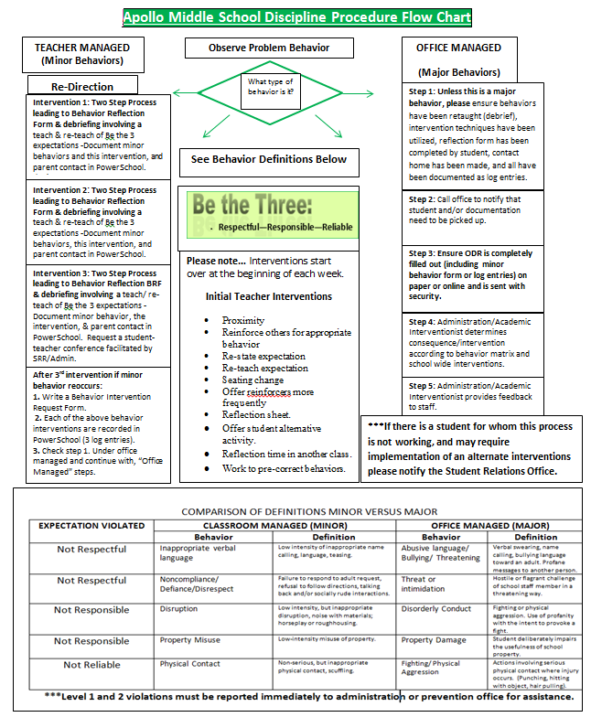

**Reflection Table**

* **If you are sitting at this desk/table, you have behaved inappropriately.**
* **You are to sit quietly at this desk/table and:**

1. **Fill out the Behavior Reflection form and reflect on why you are here.**
2. **Wait for a “break in the action” and raise your hand.**
3. **Show the BR form to your teacher and have him/her initial the form after he/she has debriefed with you.**
4. **Call your parent or guardian and tell them to expect the BR form and why.**
5. **Take the BR form home and have your parent(s) or guardian sign and date the BR form.**
6. **Return the signed BR form the next school day.**

* **Please note…Failure to return the form will result in an additional disciplinary action**

**Apollo Middle School**

**Behavior Reflection Form**

Student Name: _________________________________ Grade: 6 7 8 Date: ______ ___

Teacher: ___________________ _ Subject: __________________ Class Period: ______

“Be the 3” is what is expected of all students at Apollo. Which of these behavior expectations did you choose not to demonstrate (Be respectful, responsible, & reliable)? Please describe the incident in detail.

|  |
| --- |
|  |
|  |
|  |
|  |
|  |
|  |

What were the steps your teacher took to redirect your behavior/reinforce “Be the 3” behaviors? Please refer to Apollo MS Behavior Intervention Flow Chart for interventions your teachers may have used.

|  |
| --- |
|  |
|  |
|  |
|  |
|  |
|  |

Teacher comment after debriefing with the student: ______________________________________________________________________________________________________________________________________

Parent Comment: ______________________________________________________________________________________________________________________________________

Student Signature: _______________ ___ Teacher Signature: __ _______________

Parent Signature: ___________________ Date: _______________

***Students that do not return this form signed by the parent will be referred to the Student Relations Office.

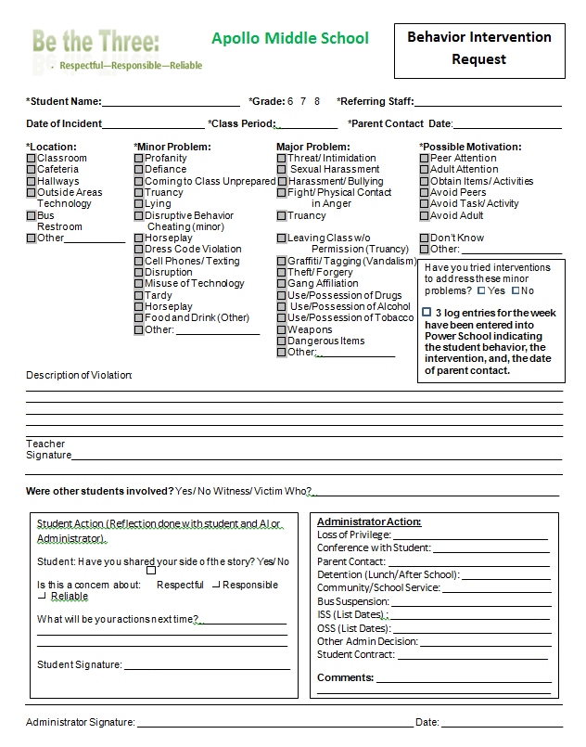

**Additional Example of CHAMPS**

**CHAMPS**

**Conversation**

* Can students engage in conversations with each other during the activity?
* How many students can be involved in a single conversation?
* How long can the conversation last?

**Help**

* How do students get questions answered?
* How do students get your attention?
* If students have to wait for help…what should they do while they wait?

**Activity**

* What is the expected end product of the activity?

**Movement**

* Can students get out of their seats during the activity?
* If yes…acceptable reason include:
* Sharpen pencil
* Get a drink of water with permission/pass
* Use the restroom with permission/pass
* Hand in/pick-up work/materials

**Participation**

* What behaviors show that students are participating fully and responsibly?
* What behaviors show that a student is not participating?

**Success!!!**

CHAMPS

Expectations for a Science Station

**C**onversation

Talk quietly with others at your station

Voice Level 1 – Whisper

**H**elp

Have two people at your station raise their hand

Keep working until I come to help

**A**ctivity

Follow the directions at the station

Answer the questions as a team

Clean up when you’re done

**M**ovement

Ok to…

Sharpen your pencil

Get a drink of water from the classroom water

fountain

Get your supplies

**P**articipation

Talk quietly with other members of your group

Stay focused on working and talking about the project

Don’t disturb other stations

**S**uccess!

Work together to learn together!