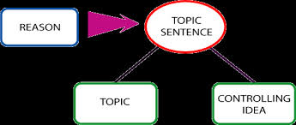

**Controlling Idea / Topic Sentences**

**Controlling Idea**

1. The controlling idea is the main idea that the writer is developing in an essay. The controlling idea usually expresses a definite opinion or attitude about the topic of the essay.

2. The controlling idea can be supported within the paragraphs of the essay.

3. The controlling idea gives direction to the essay. It lets the reader know what to expect, and it gives a definite focus to the entire essay.

4.It is the controlling idea that ties all the paragraphs together and makes them part of the larger essay concept.

5. Without a controlling idea, the essay lacks focus. The writer has nothing to center the essay on, and the reader may not know the writer’s point.

**Topic Sentences, Details and Concluding Sentence**

1. A topic sentence expresses the main idea of the paragraph.

2. A topic sentence usually states a definite opinion or idea.

3. A topic sentence provides the reader with a clear understanding of what a paragraph is going to be about.

4. A topic sentence gives direction to the paragraph that both the reader and writer can follow.

5. A topic sentence often begins a paragraph or is found near the beginning of the paragraph.

6. Other sentences within a paragraph relate to the topic sentence.

7. The final “wrap-up” sentence, or concluding sentence, within a paragraph often reinforces the topic sentence.

**Some Pointers in Writing Topic Sentences**

1. A good topic sentence usually states an opinion or attitude that can be supported by details and examples.

2. A good topic sentence is specific enough to be clear and interesting.

3. A good topic sentence gives a definite direction to a paragraph.