**NAMES: Date: Period:**

**TOPIC: Creating your own Business**

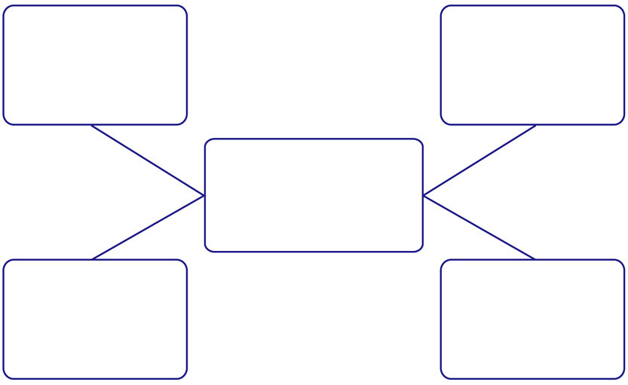

Name of your Business:

Will you be selling anything? If so what is your product? How much will your product cost?

Will you be helping people with your business? How will you be helping them?

How will people use your business and why would people use your business?

What will your business do?

-Add any details for your business that you feel is important.