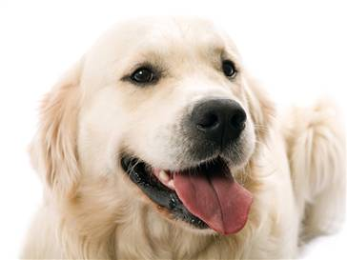
Golden Retriever
The golden retriever, whose trademark is its light to dark golden-colored coat, possesses great intelligence and an eager-to-please attitude. The golden retriever makes an ideal service and search-and-rescue dog. This active and energetic breed can adapt to many different living situations as long as he has plenty of daily exercise. His water-repellent double coat sheds seasonally and needs regular brushing. With his friendly temperament and striking golden color, this breed is both beautiful to look at and a joy to own.

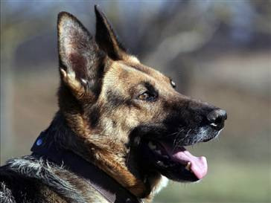
German Shepherd
The German shepherd dog is hailed as the world’s leading police, guard and military dog, however, this dependable breed is more than just a hard worker. It is also a loving family companion, herder and show competitor. The breed is approachable, direct and fearless, with a strong, muscular body, and can be most colors except white. Energetic and fun-loving, this breed is a loyal family pet, a good guard dog and the ideal choice for many families. He requires regular exercise and grooming.

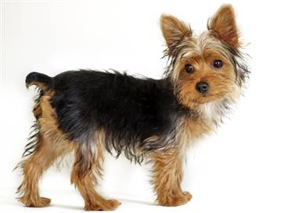
Yorkshire Terrier
Yorkshire terriers, affectionately known as “Yorkies,” offer big personalities in a small package. Terriers by nature and are brave, determined, investigative and energetic. They have long, luxurious blue-and-tan coats that require regular brushing. This portable pooch is easily adaptable to all surroundings, travels well and makes a suitable pet for many homes. Due to their small size (they weigh only 4 to 7 pounds), they require limited exercise, but need plenty of daily interaction with people.

