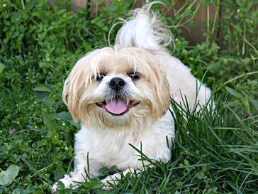
Shih Tzu
A compact and solid dog, the shih tzu’s long, flowing double coat is its most distinctive feature. Shih tzu means “lion” and although this dog is sweet and playful, he is not afraid to stand up for himself! Since the sole purpose of the shih tzu is companion and house pet, he should be lively, alert, friendly and trusting toward all. Weighing between 9 and 16 pounds, he requires minimal exercise, but his long, luxurious coat needs daily brushing and maintenance.

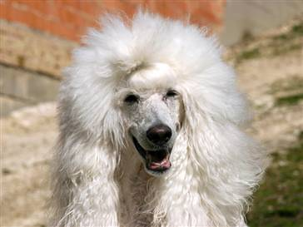
Poodle
The poodle, though often considered high maintenance due to its coat, is actually one of the high achievers of the canine world. The breed is exceptionally smart, hardy and excels in obedience training. His coat – coming in a variety of solid colors, including white, black, apricot and gray – is also hypoallergenic, which may reduce allergic reactions.

Bulldog
Known for their loose-jointed, shuffling gait and massive, short-faced head, the bulldog is known to be equable, resolute and dignified. A medium-sized dog, they are not your typical lap dog, but would like to be! Bulldogs are very popular due to their lovable and gentle dispositions and adorable wrinkles. Bulldogs are recognized as excellent family pets because of their tendency to form strong bonds with children. They tend to be gentle and protective. The breed requires minimal grooming and exercise, but their short nose makes them prone to overheating in warm weather.

