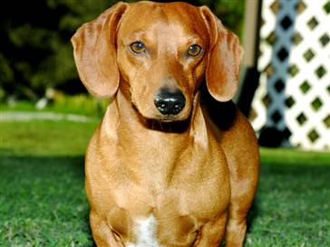
Dachshund
The dachshund, meaning “badger dog” in German, is a lively breed with a friendly personality and keen sense of smell. Known for their long and low bodies, they are eager hunters. The breed can be miniature (11 pounds and under) or standard size (16-32 pounds). Dachshunds are lovable, playful companions, and an ideal pet for many homes. They require moderate exercise, and can adapt to most living environments. Depending on their coat type, dachshunds may need regular grooming.

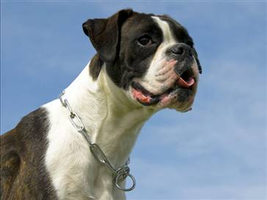
Boxer
The well-conditioned middleweight athlete of dogdom, the boxer is a powerful dog with an intelligent and alert expression. While they are instinctive guardians, the boxer loves to be with his people. One of the breed’s most notable characteristics is its desire for human affection, especially from children. They are patient and spirited with children, but also protective, making them a popular choice for families. The boxer’s short coat requires minimal maintenance, but he is an active dog that needs daily exercise.

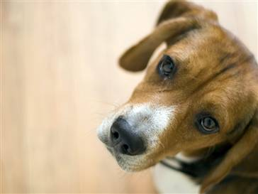
Beagle
The beagle is a sturdy hunting dog. His easy-to-care-for coat, combined with a merry personality, has made the beagle a favorite of many families over the years. Today’s beagle comes in two height varieties (13 inch and 15 inch) and any true hound color, including tri-color, red and white and lemon. Beagles are happy-go-lucky and friendly, making them a wonderful family pet. Curious and comedic, they often follow their noses – which can lead to some mischief if they are not provided with daily activity.

