We made it through the first nine days of school. Many who have returned are probably wondering why we started early this year. We will have a full 1 week fall break and 2 weeks for spring break.

Please read and review classroom rules with your child, sign and return the letter by Monday, August 17th.

No Classes:
FRIDAY, AUGUST 14TH AND 28TH.

What your child will be learning:
Reading: Identifying letters, sounds, vowels and reading sight words and short story books.

Writing:
- Opinion piece based on the story Lulu and the Brontosaurus.
- Using clues, making predictions, and sequencing events.
- Using vocabulary and graphic organizers to support opinion writing.

Math:
- Counting individual objects
- Write numbers 0 to 20
- Count out loud to 100 (120 by end of quarter)
- Identify #’s 1-120
- Use ten frames to represent #’s 0-20
- Make combinations of 10
- Use groups of 10 when counting objects
- Circle groups of 10 in picture representations
- Bundle groups of 10 objects
- Represent teen ‘s using 10’s
- Justify and explain thinking orally and in written form

Grammar:
- Physical action verbs
- Common nouns (singular and plural)
- Proper nouns
- Articles

Procedures: Rules, bathroom, walking, using an inside voice, taking care of school property, school etiquette and treating others with respect are all procedures practiced and reviewed on a daily basis.

Homework
Homework will be sent out on Monday and is to be returned on Friday. There is no school this Friday, therefore homework is due Monday, August 17th.

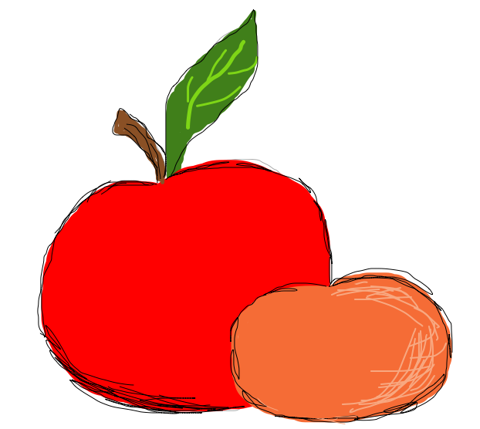Snack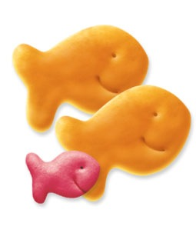 Calendar
I have attached a snack calendar ONLY to those whose names are listed on the calendar. Please look for your child’s name and, if you are able to donate snacks on your child’s assigned day, please send it with him or her. There are 28 students in our class. Snacks may consist of Gogurt, pretzels, popped popcorn, crackers, cut up fruits or vegetables and/or Capri Sun juice.

New School Hours:
Mon-Tues/Thurs-Fri. 8:30-3:00
Wednesday: 8:30-12:45

If there is ANY change in your child’s transportation, PLEASE call the office regarding the change. Thank you☺

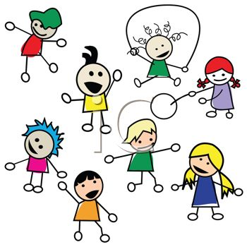Every Wednesday, your child has P.E. Please make sure he or she wears comfortable clothes and tennis shoes.

Uniforms:
Uniforms must be worn daily. Uniforms consist of khaki or blue pants, shorts/skorts, dresses with white, blue or gray polo shirts. Children are allowed to wear tennis and sandals with straps. Flip flops are not allowed.

If you have any questions or concerns, please don’t hesitate to call me at 545-2600.


We will have an “End of the Year” celebration on Friday, May 20th from 2:45-3:30.
Vamos a tener una celebración para finalizar el ano escolar. El viernes, 20 de mayo. Empezara a las 2:45-3:30.

Kindergarten promotion will be on Tuesday, May 24th at 9:30. Your child does not have to wear his/her uniform.
La celebración del kinder será el martes, 24 de mayo. La ceremonia va a ser a las 9:30 y su hijo/a no tiene que usar su uniforme!


There will be no homework this week or next.
No habrá tarea esta semana.



On Friday, May 20, the children will watch the fifth graders play softball. Please send your child with shorts, tennis shoes and/or a hat. If you would like, you can send him/her with bottled water. Thank you☺

El viernes, 20 de mayo, los niños van a ver los estudiantes de quinto grado jugar béisbol. Por favor, mande su hijo/a con zapatos de tenis, pantalones cortos y/o un gorra. Si gusta, puede mandar una botella de agua con su hijo/a. Gracias☺

The school year is coming to an end. There are only 7 days left!

